**Selected - 1**



**Number Team : 2**

1. Moatasem Mohamed Ragab 202000928
2. Hana Mohamed Zein 202001039
3. Aya Raaft Mtwaly 202000184
4. Emad Mostafa Serag 202000580
5. Mohamed Ali Moslh 202000804
6. Yasmeen Hamdy Abdo 201900958

**Faculty Name : Computers and artificial intelligence Helwan**

**Image Dataset**

**\*\*General Information :**

**1. The Name** **Dataset : Cell Images For Detectiong Malaria.**

**2. Number of** **Classes : 1**

**Their Labels: 2**

**3.Total Number of** **Samples : 27558 Do Augmentation On Dataset = 96453 Samples**

**The Image** **Size : 70*70*3**

**4.** 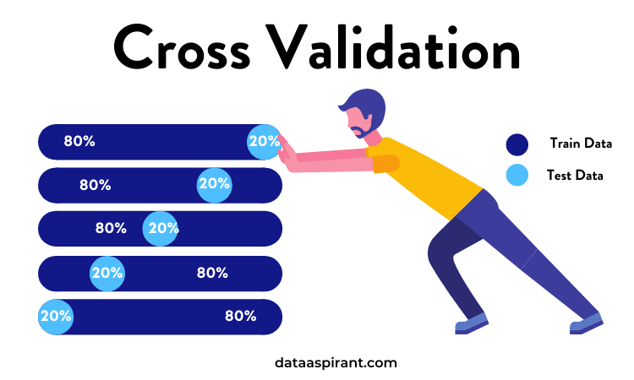

**Number of Training : 62162**

**Number of Validation : 15000**

**Number of Testing : 19291**

**Implementation Details:

**1. At feature extraction phase :**

**How many features : 5**

**Their names : 1.Resizing and Scaling.**

**2.Sharpen Image.**

**3.Bulling The Image.**

**4.Image Array.**

**5.Distribution of Pixel**

**Value.**

**The dimension of resulted : 3 Dimensions**

**2. Is cross-validation used? Yes**

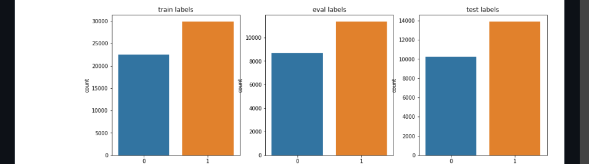

**Number of Training : 62162 = 64.5%**

**Number of Validation : 15000 = 15.5%**

**Number of Testing : 19291 = 20%**

**Number of K Fold : 5 Fold.**

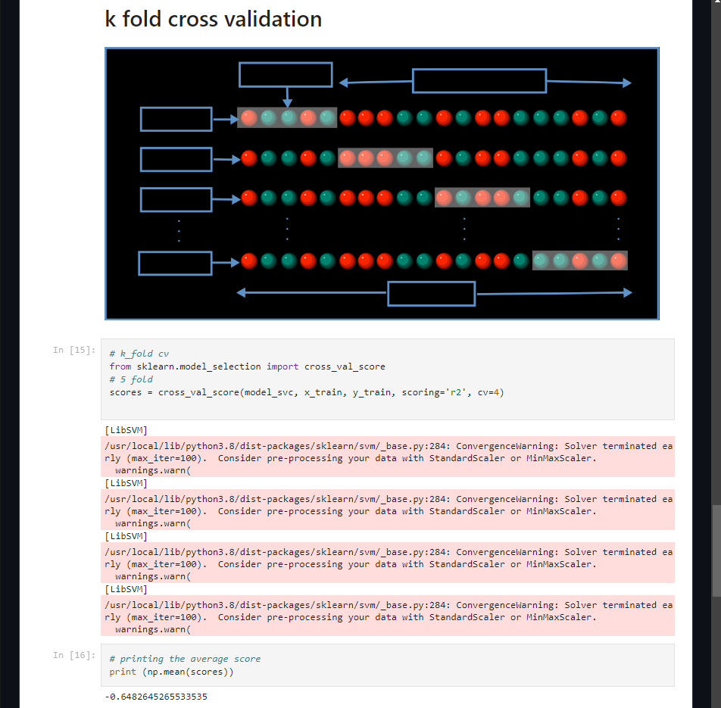

**3.Hyperparameters used:**

**1. Learning Rate = 0.1**

**2. Optimizer : Adam "tensorflow"**

**3. Regularization : Overfit the Dataset :**

**a. Traning Not Big**

**b. Fewer Layer**

**c. Dropout** 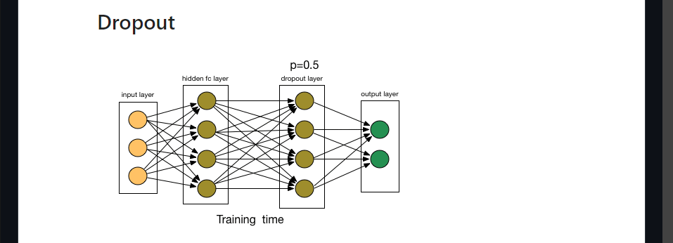

**d. Early Stopping**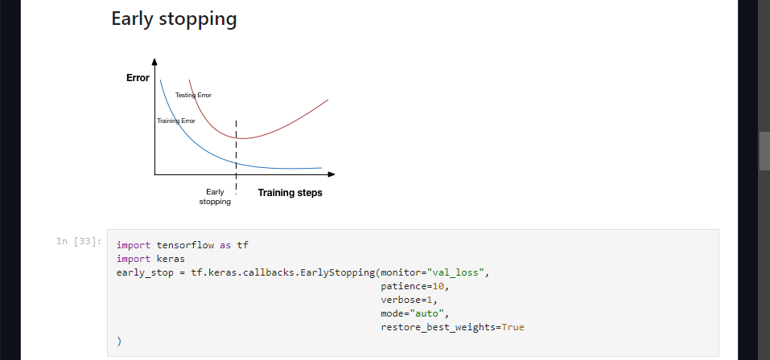

**4. Batch Size = 128**

**5. Number of epochs = 100**



**" We use 100 epochs, stopped in 30 epochs with accuracy = 66% Then we increase epochs to 41 epochs with accuracy = 75%"**

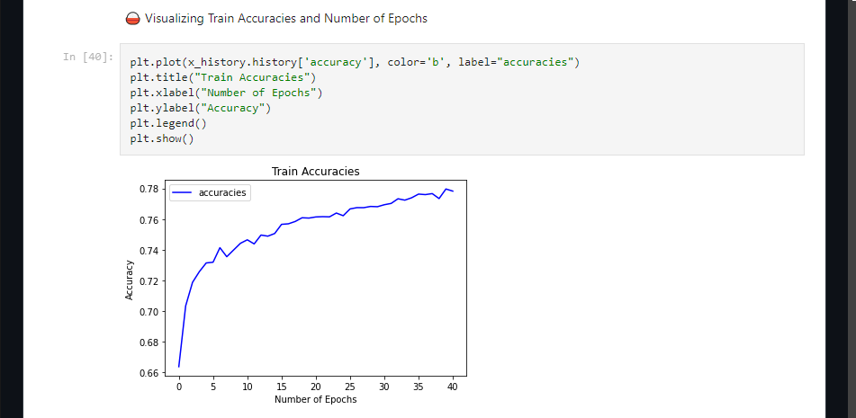

**\*\*Results Details:**

**1. Loss curve :**

**a. Train loss & Accuracy:**

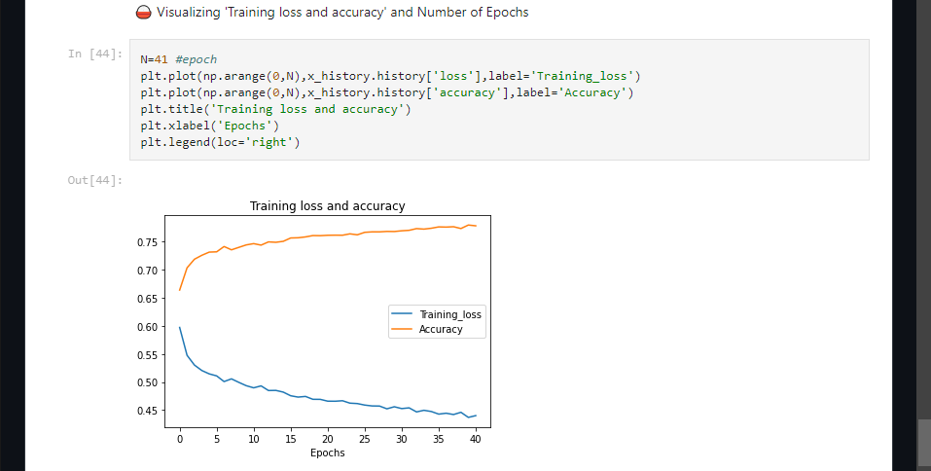

**b. Training & Validation loss:**

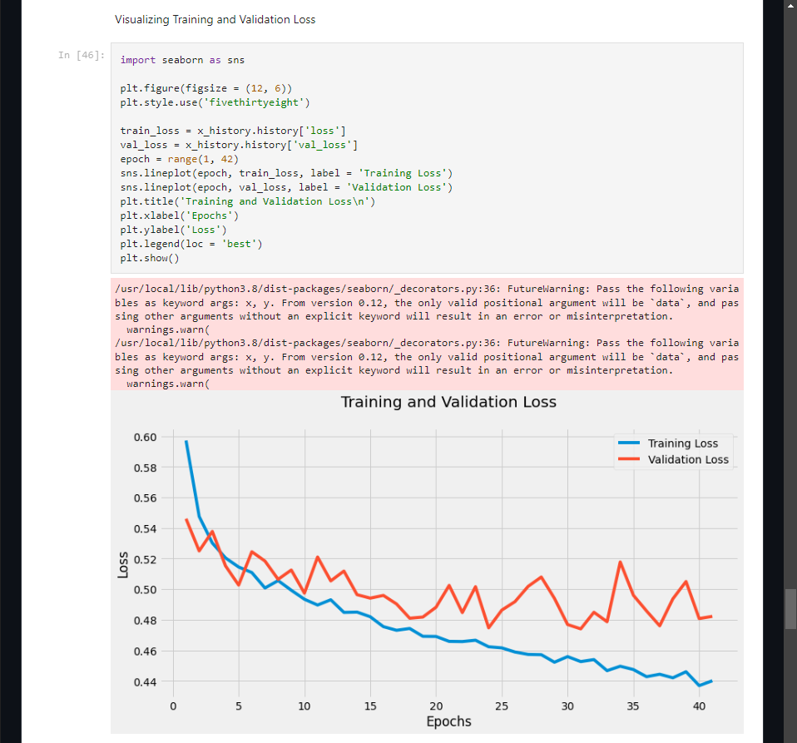

**2.** **Accuracy :**

**\* Training & Validation Accuracy:**

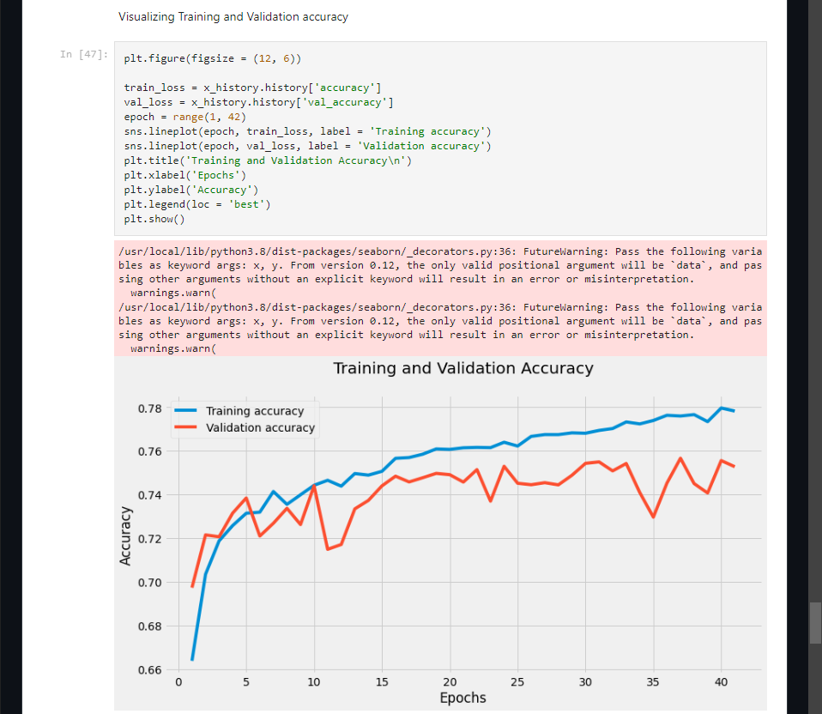

**3. Confusion Matrix:**

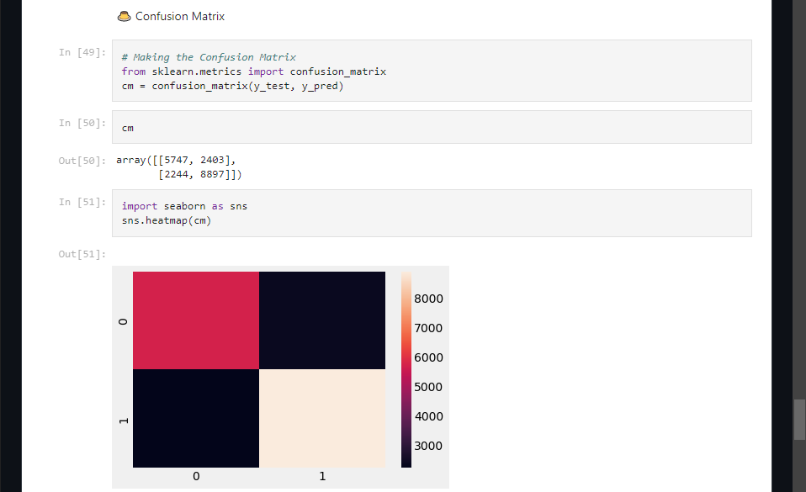

**4. ROC Curve:**

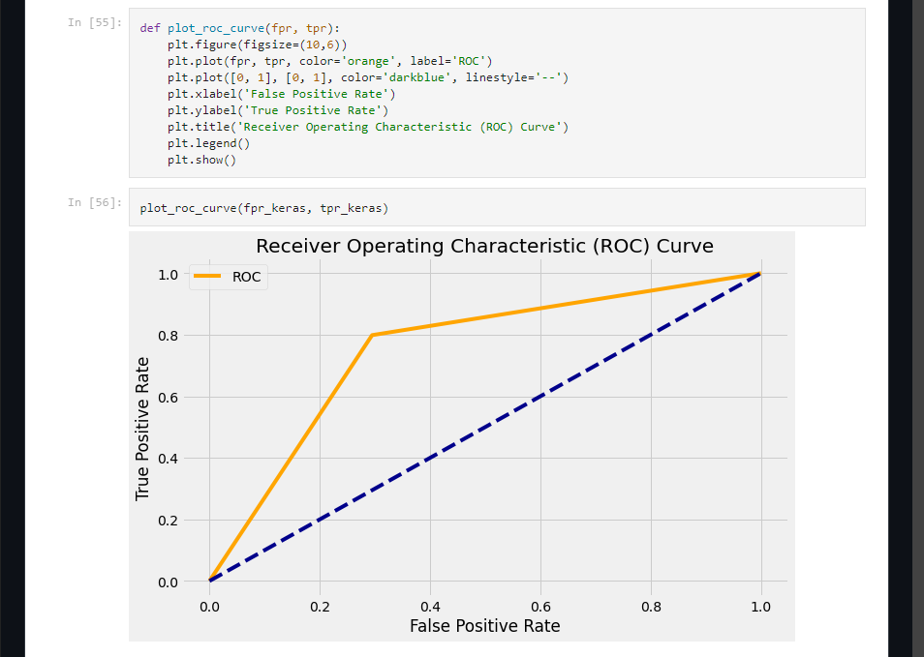

** Classification Report :

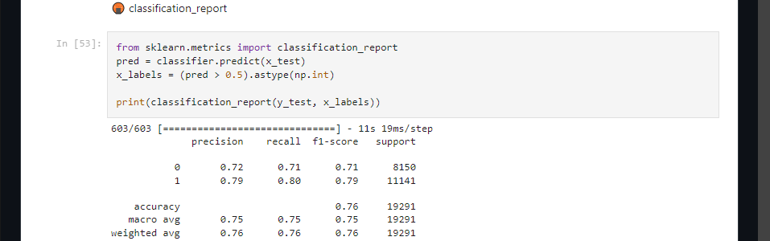

**Numerical Dataset**

**\*\*General Information :**

**1.The Name of Dataset : Healthcare Dataset Stroke.**

**2. Number of Classes : 2**

**Their Labels: 22**

**3.Total Number of Samples : 5110.**

**4. Number of Training : 3436**

**Number of Validation : There is no Validation**

**Number of Testing : 860**

**Implementation Details:

**1. Is cross-validation used? Yes**

**Number of Training : 3436**

**Number of Testing : 860**

**Number of K-Fold : 5**

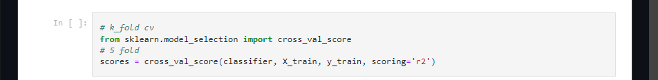

**3.Hyperparameters used:**

**1. Optimizer : Adam "tensorflow"**

**\*\*Results Details:**

**1.SVM:**

**\***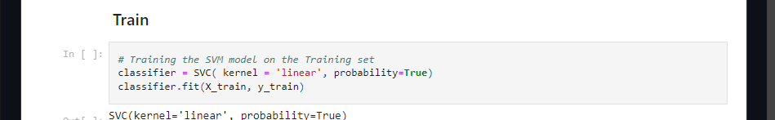

**\* Accuracy:**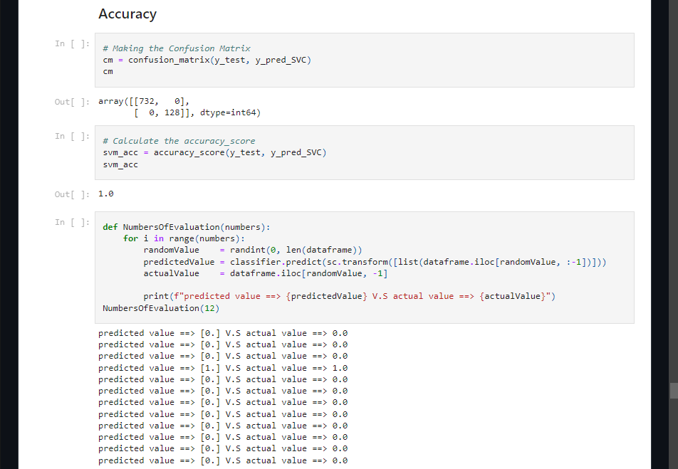

**\*\*Classification-report:**

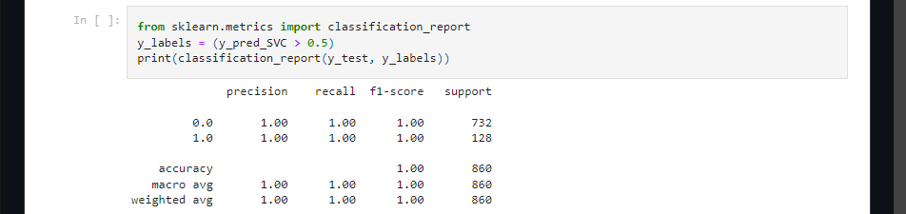

**\*\***

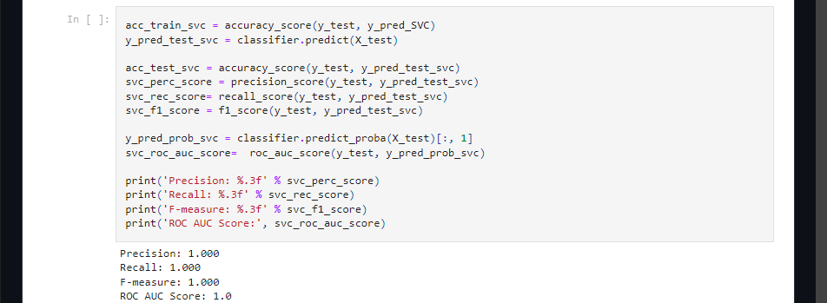

**\*\*Confusion Matrix:**

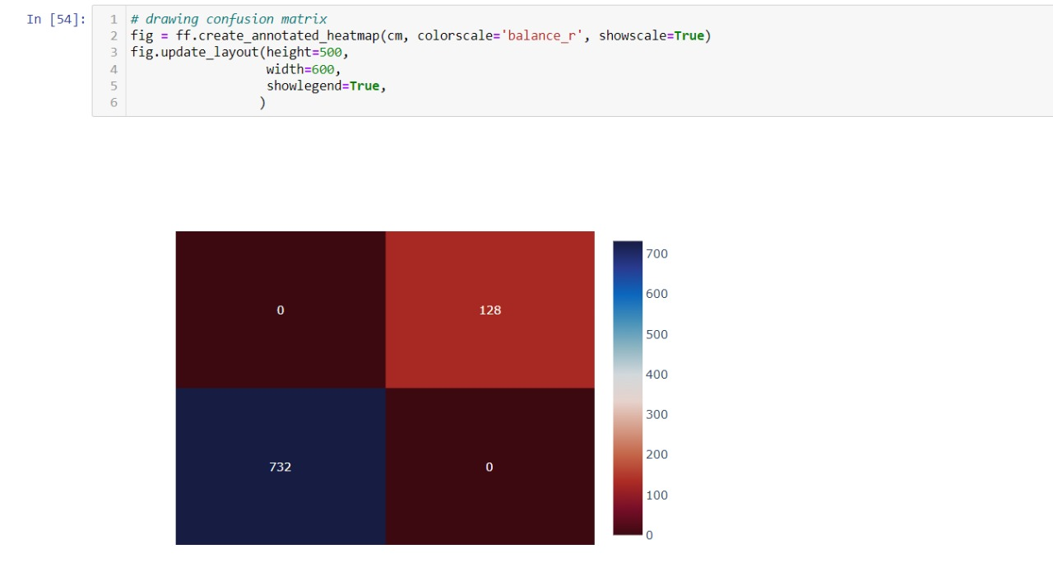

**\*\*ROC :**

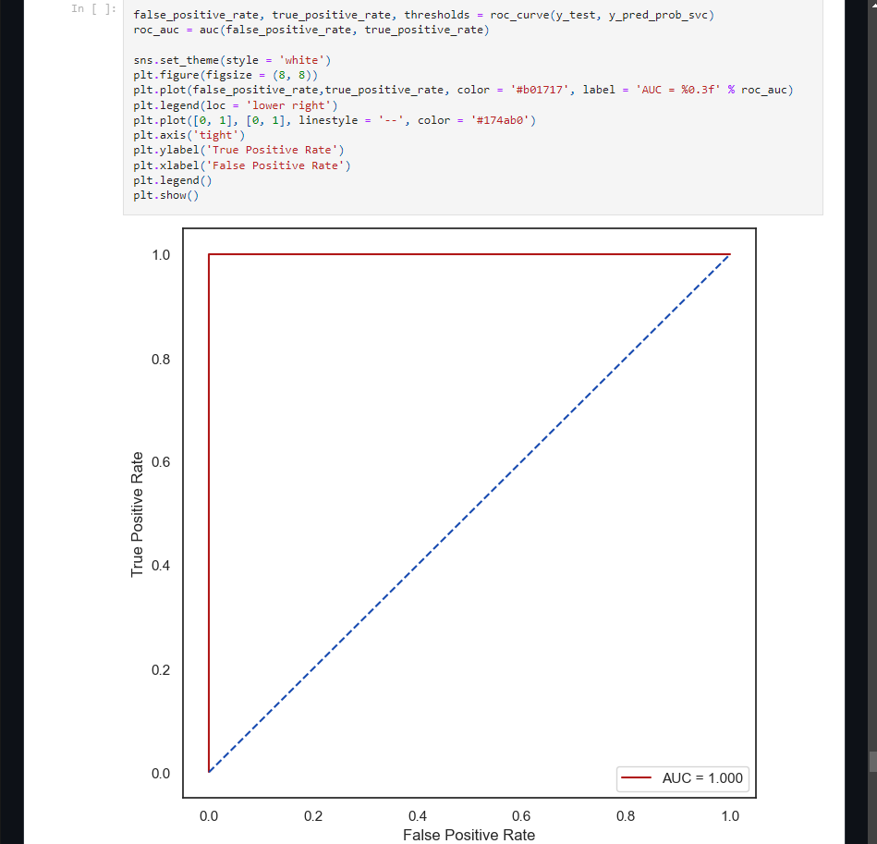

**\*\* Final Result :**

